Total Station
# Source: AI Source: Provided by: [Data Path: Persons Table -> ID Column: 1, Name_En Column: Motasem Essam] -> From: [ChatGPT] on [7/17/2026]
A Total Station is an advanced electronic surveying instrument that combines an electronic theodolite, an electronic distance meter (EDM), and a microprocessor into a single device. It is capable of measuring horizontal angles, vertical angles, slope distances, and automatically computing coordinates, elevations, and positions.
Total stations are widely used in surveying, civil engineering, construction, mapping, mining, transportation, archaeology, and geospatial engineering.

Definition
# Source: AI Source: Provided by: [Data Path: Persons Table -> ID Column: 1, Name_En Column: Motasem Essam] -> From: [ChatGPT] on [7/17/2026]
A Total Station is an integrated electronic surveying instrument that measures angles and distances while automatically calculating coordinates, elevations, and other surveying data.

Purpose
# Source: AI Source: Provided by: [Data Path: Persons Table -> ID Column: 1, Name_En Column: Motasem Essam] -> From: [ChatGPT] on [7/17/2026]
A total station is used to:
- Measure horizontal angles.
- Measure vertical angles.
- Measure distances.
- Determine coordinates.
- Calculate elevations.
- Perform topographic surveys.
- Lay out buildings, roads, and bridges.
- Monitor structural deformation.
- Produce digital survey data.

Principle of Operation
# Source: AI Source: Provided by: [Data Path: Persons Table -> ID Column: 1, Name_En Column: Motasem Essam] -> From: [ChatGPT] on [7/17/2026]
A total station combines three primary technologies:
- Electronic Theodolite – measures horizontal and vertical angles.
- Electronic Distance Meter (EDM) – measures distance using laser or infrared light.
- Microprocessor – processes measurements and computes coordinates.
The instrument sends an electromagnetic signal to a prism (or directly to a surface in reflectorless models). By measuring the travel time or phase shift of the returned signal and combining it with the measured angles, it calculates the exact position of the target.

Main Components
# Source: AI Source: Provided by: [Data Path: Persons Table -> ID Column: 1, Name_En Column: Motasem Essam] -> From: [ChatGPT] on [7/17/2026]
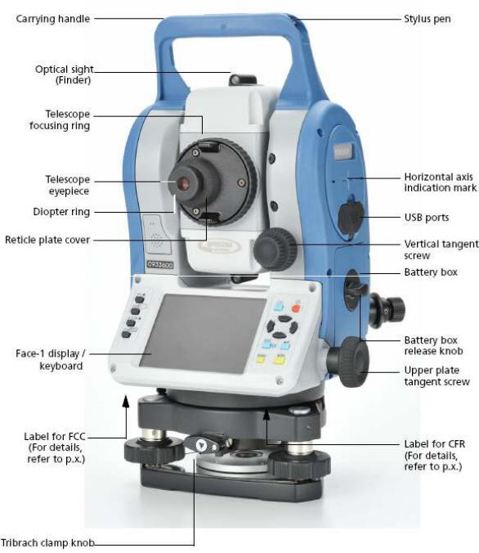
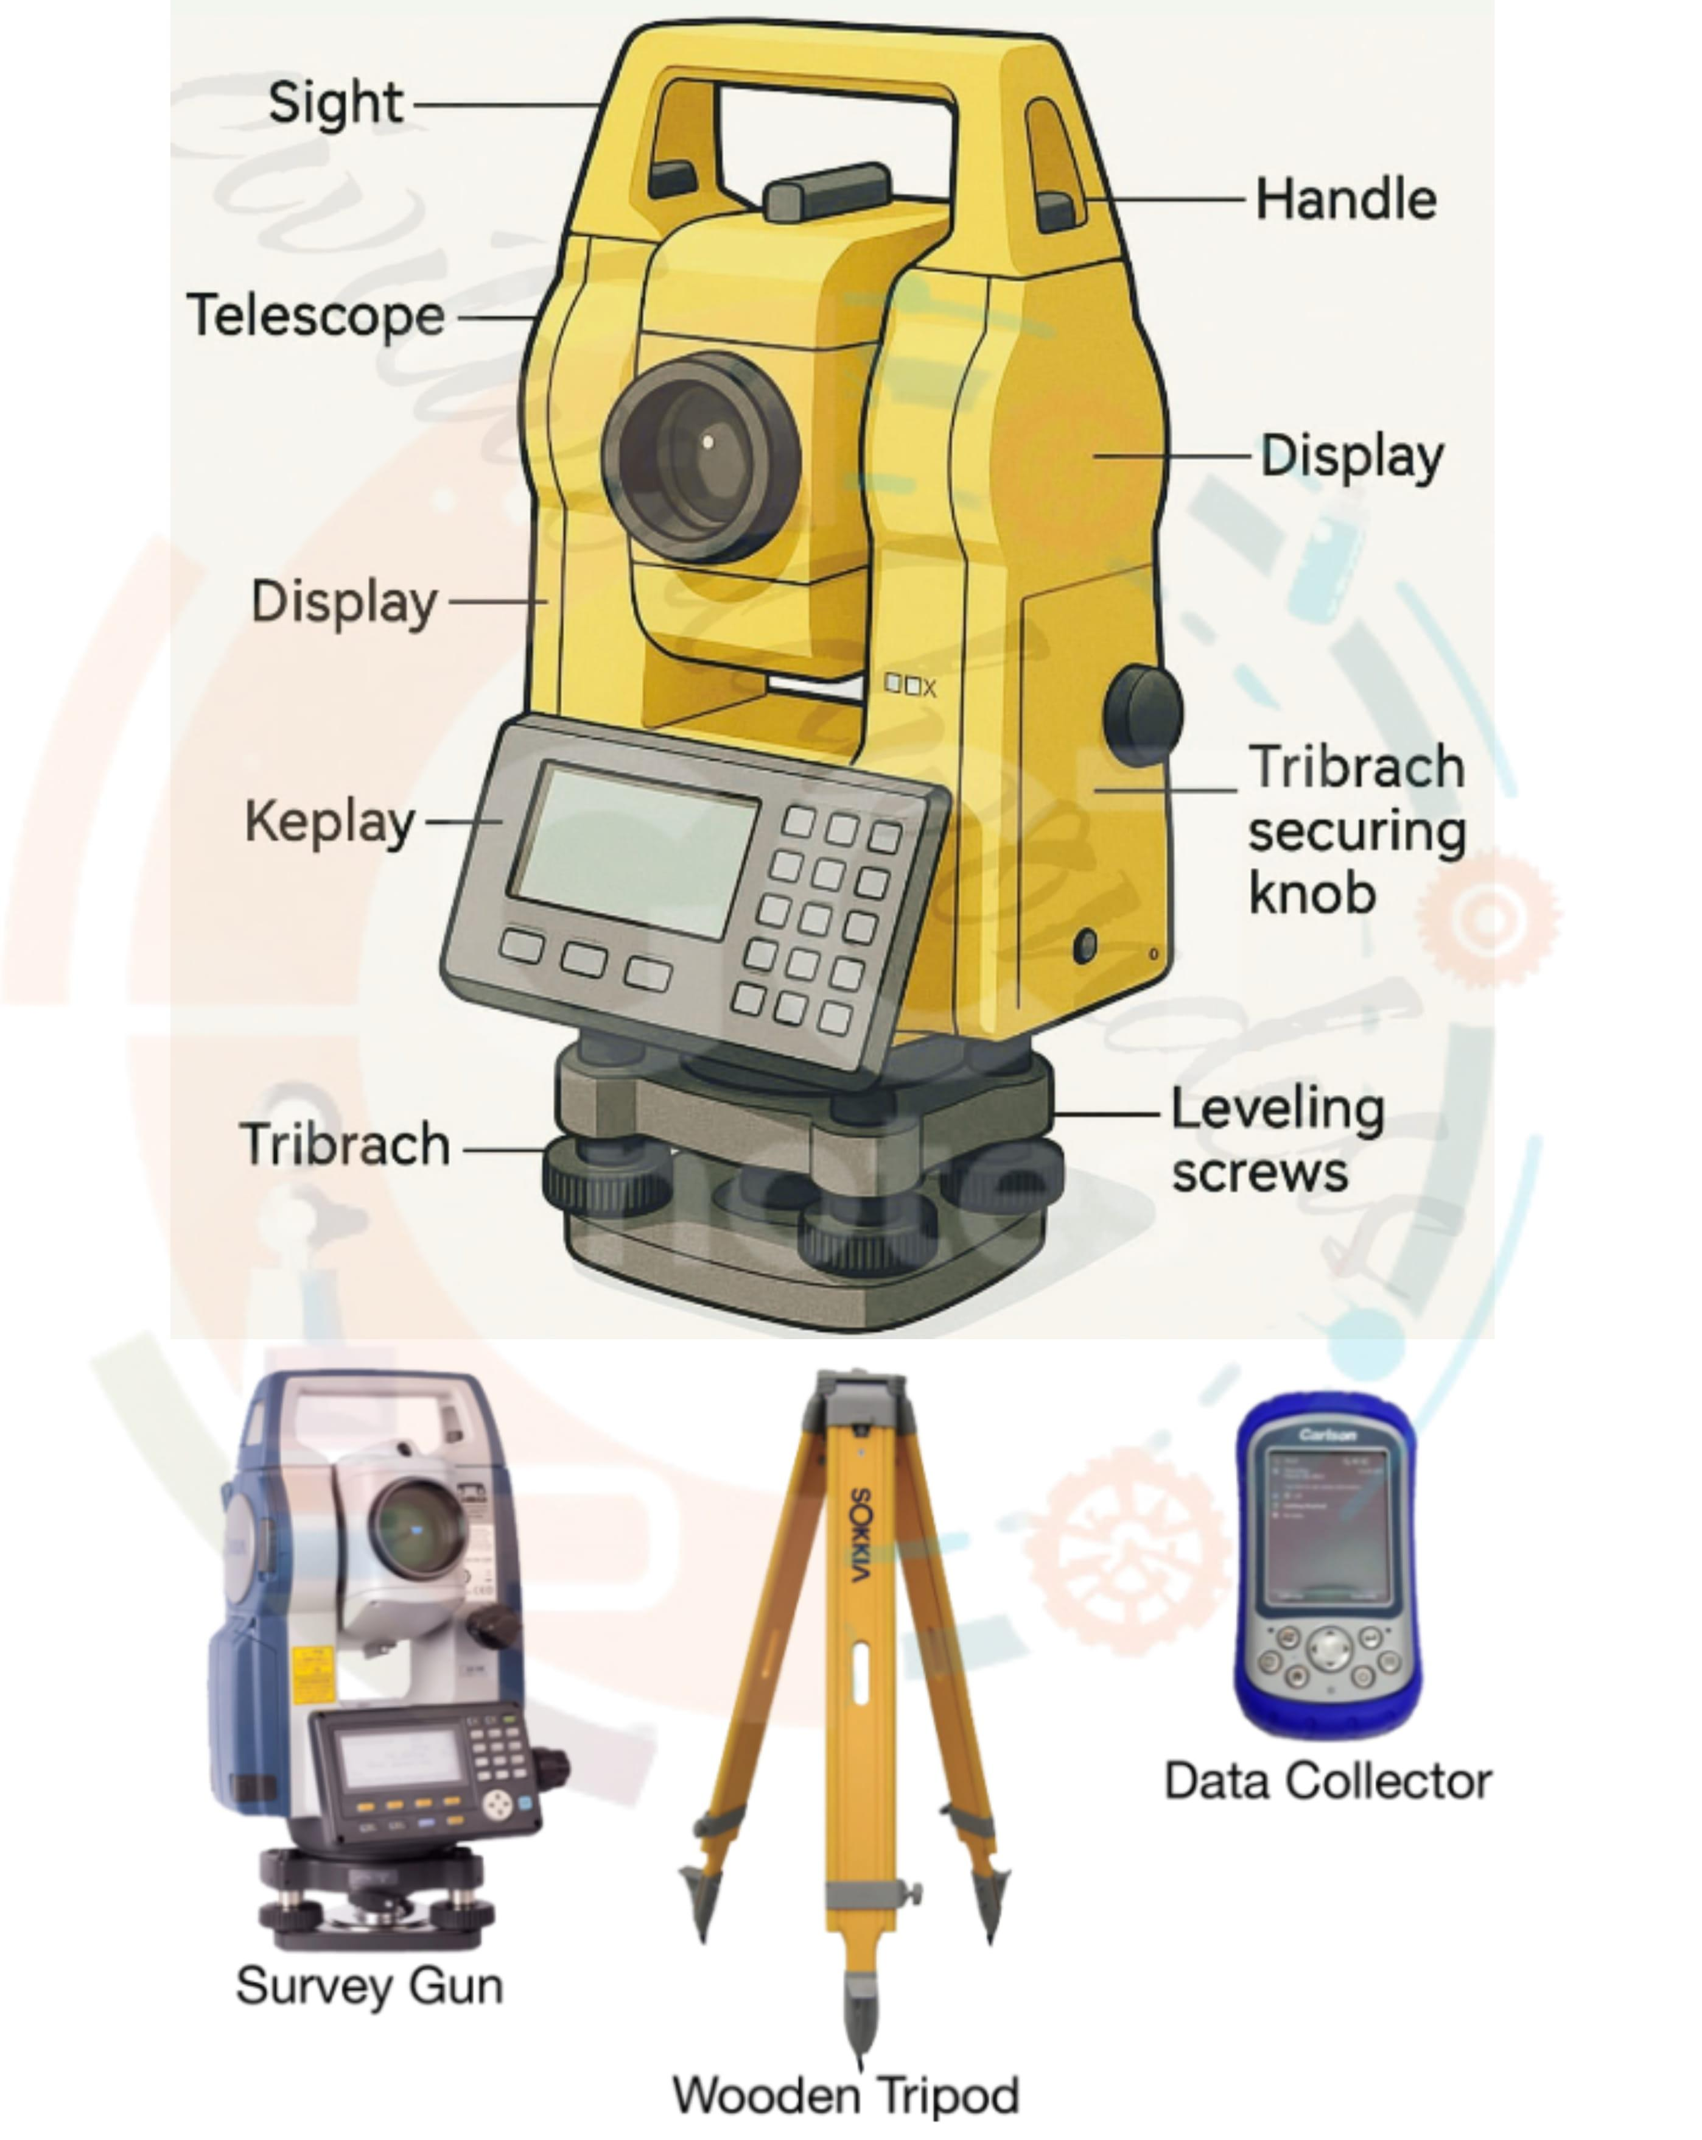
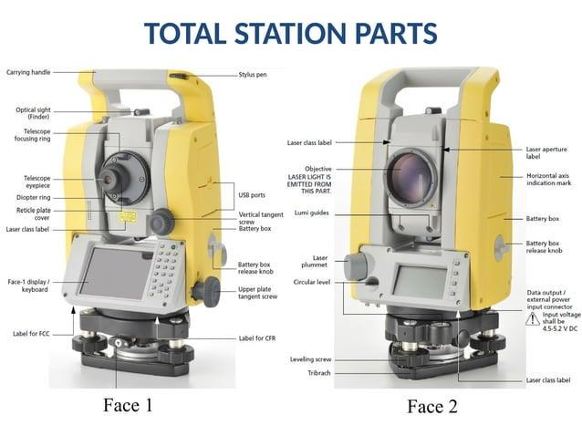
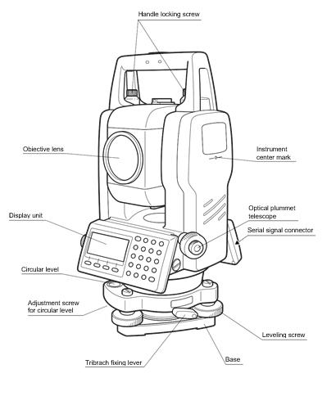
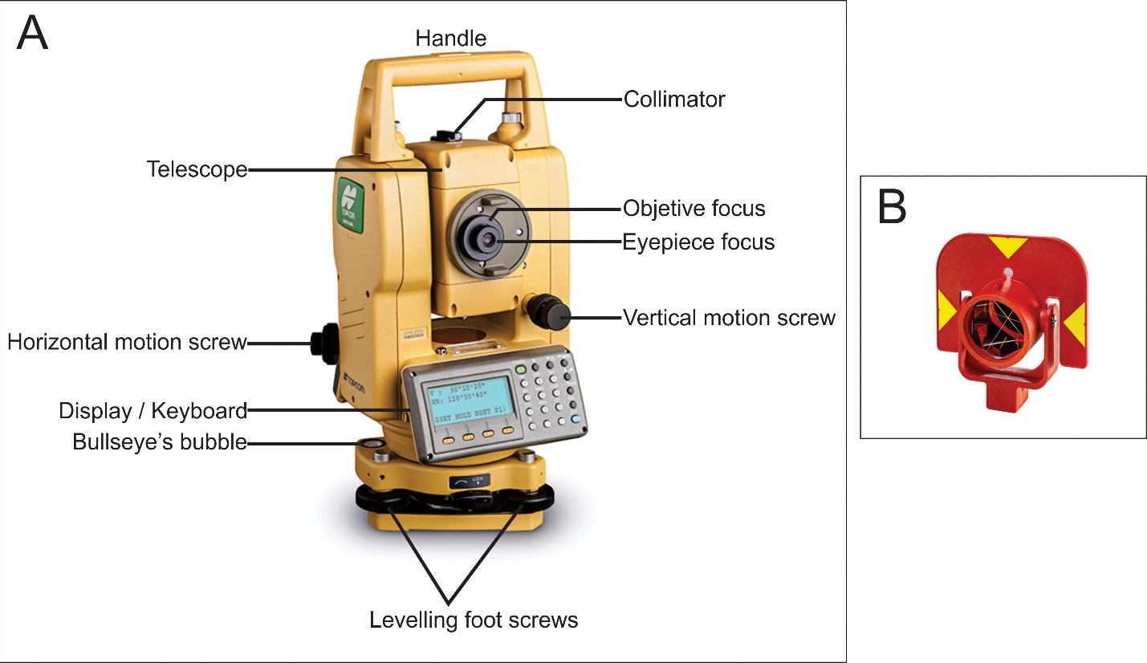
A typical total station consists of:
- Telescope
- Electronic Distance Meter (EDM)
- Horizontal angle encoder
- Vertical angle encoder
- LCD display
- Keypad or touchscreen
- Microprocessor
- Internal memory
- Battery
- Tribrach (base)
- Leveling screws
- Optical or laser plummet
- Tripod

Types of Total Stations

1. Conventional Total Station
# Source: AI Source: Provided by: [Data Path: Persons Table -> ID Column: 1, Name_En Column: Motasem Essam] -> From: [ChatGPT] on [7/17/2026]
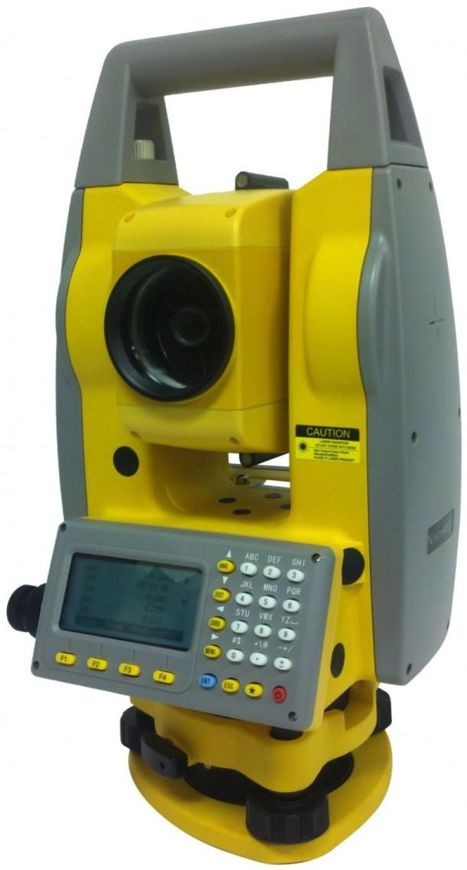
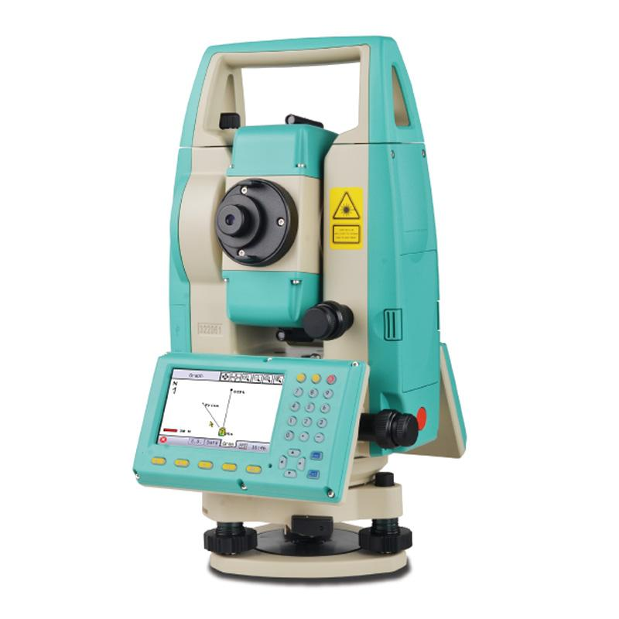
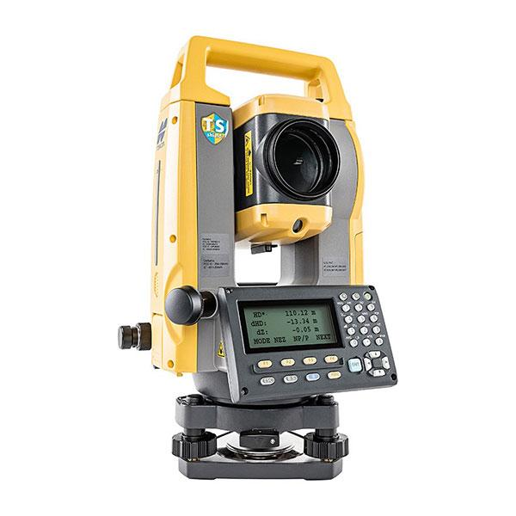
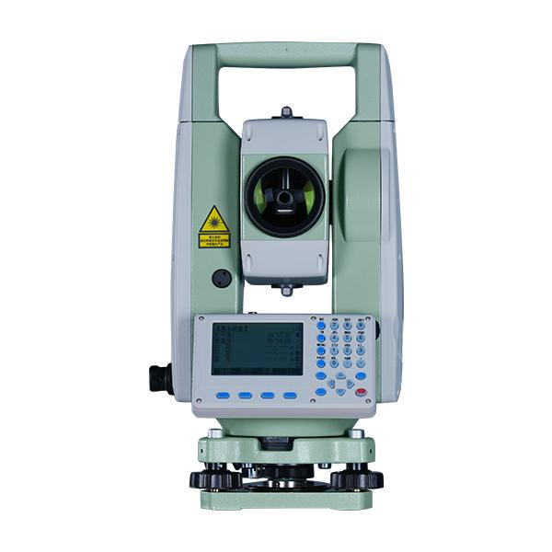
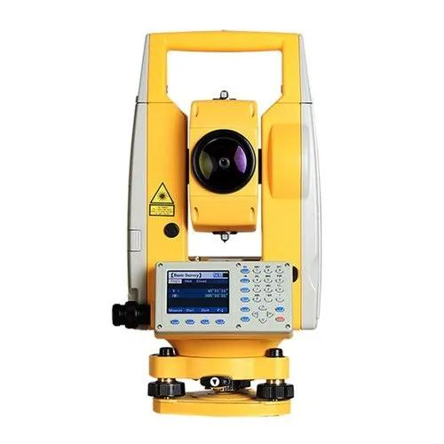
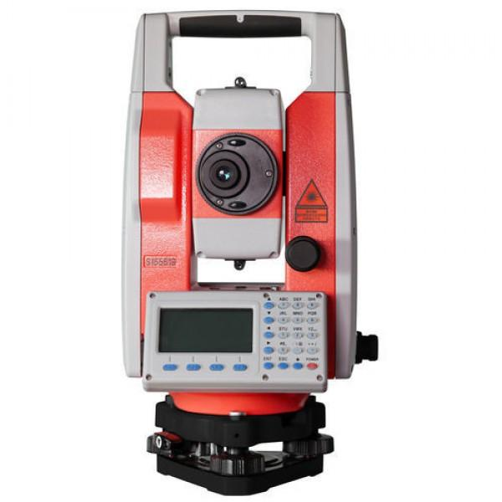
Description
Requires a surveyor to manually aim the telescope and record points.
Applications
- General land surveying
- Construction layout
- Topographic surveys

2. Robotic Total Station
# Source: AI Source: Provided by: [Data Path: Persons Table -> ID Column: 1, Name_En Column: Motasem Essam] -> From: [ChatGPT] on [7/17/2026]
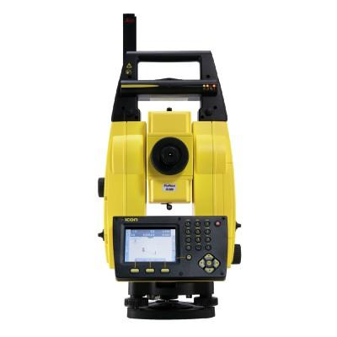
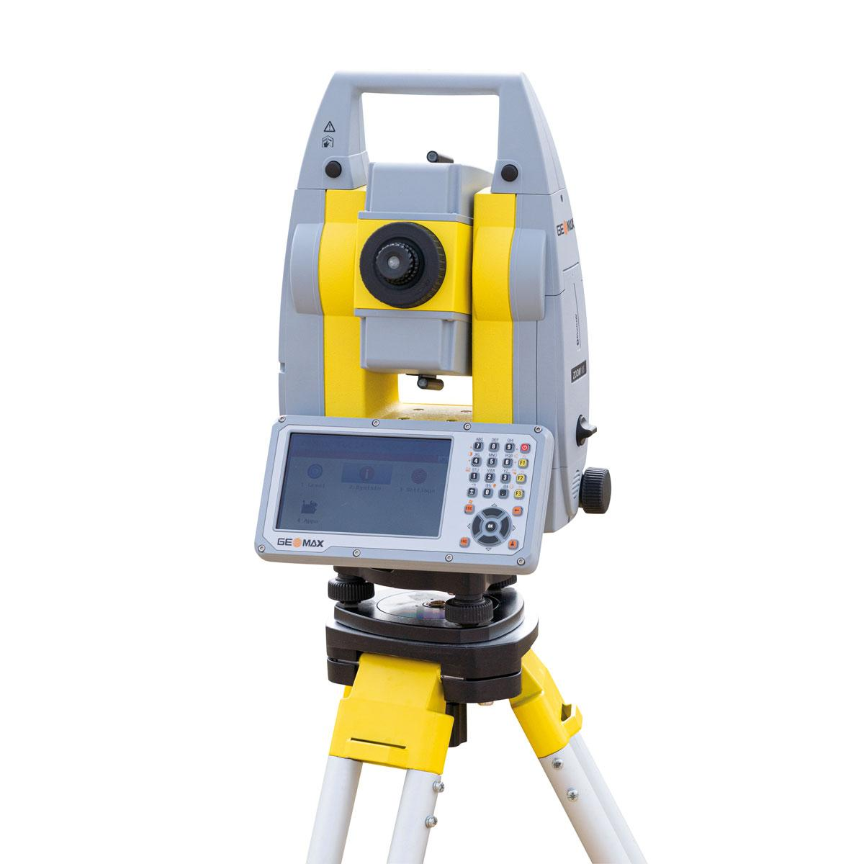
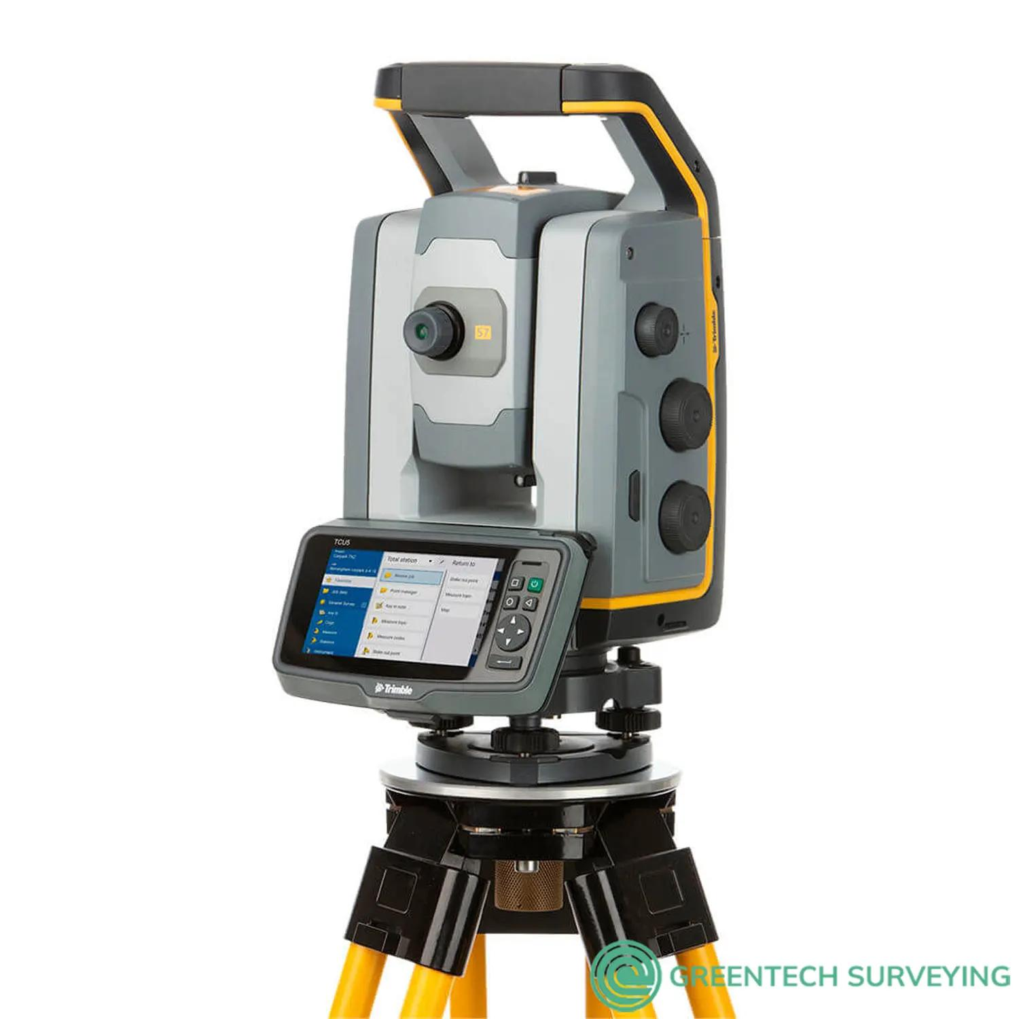
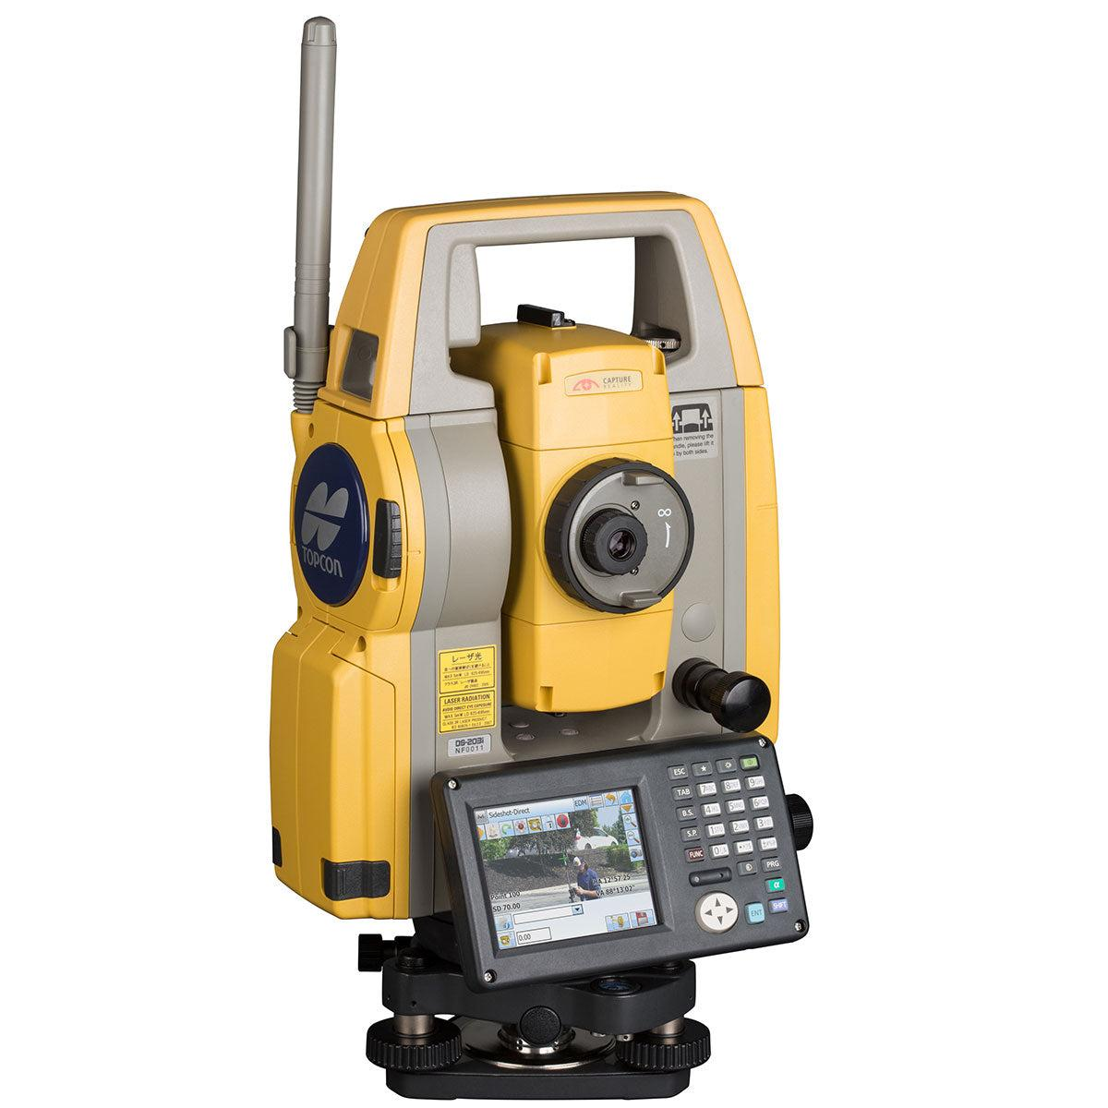
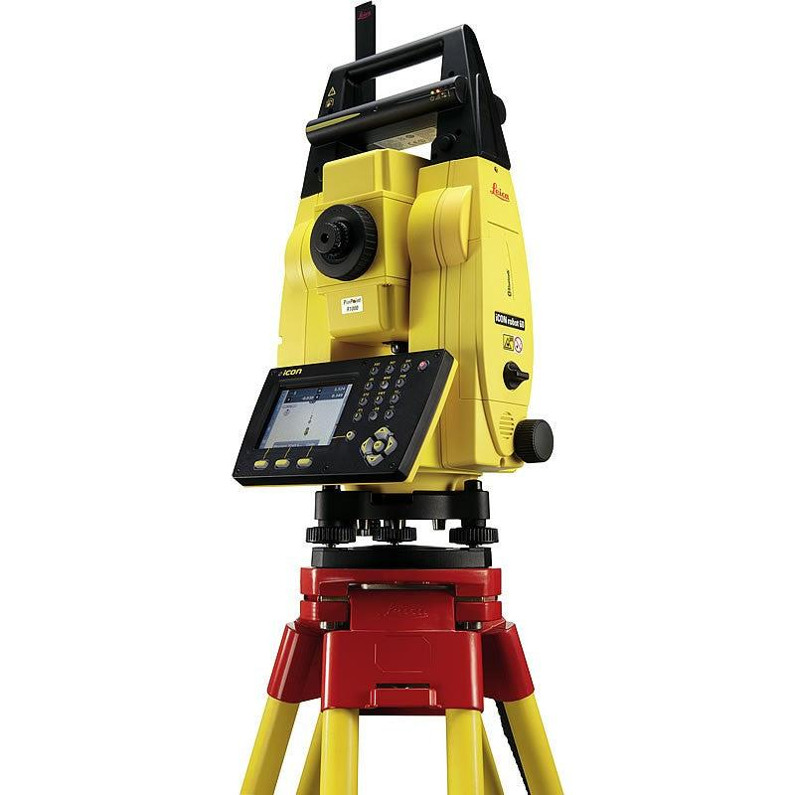
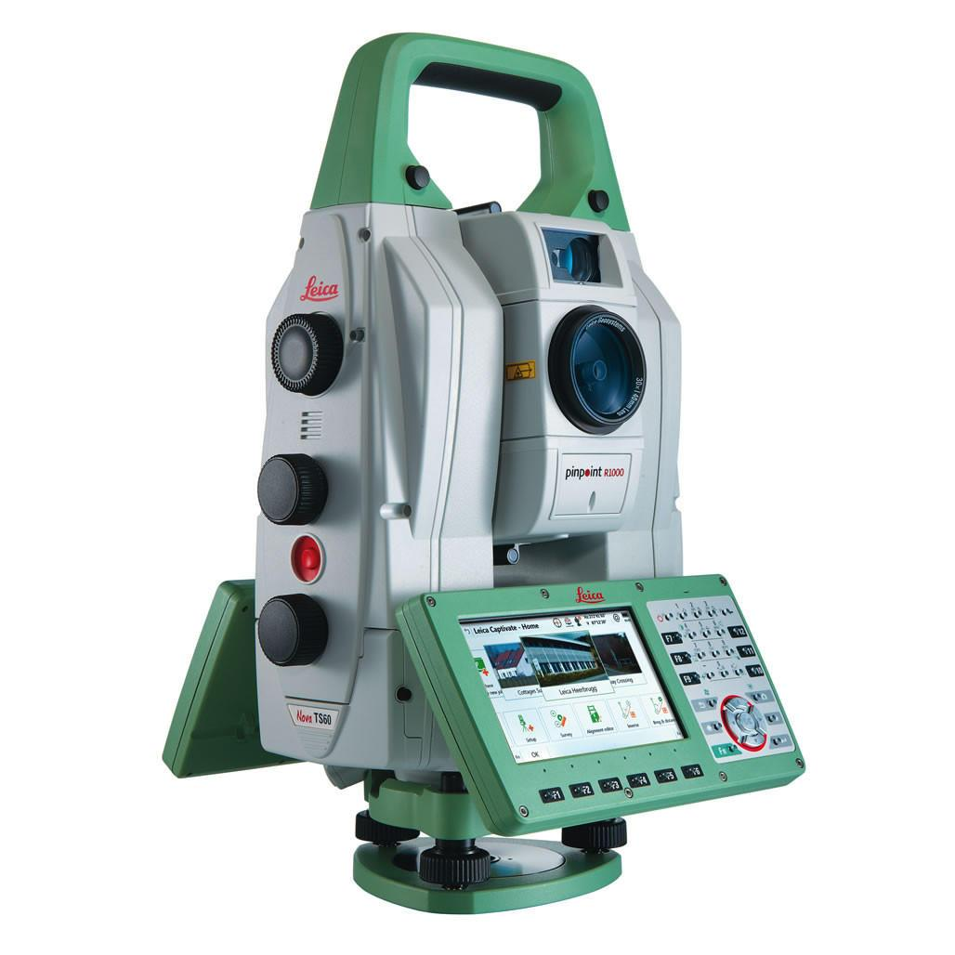
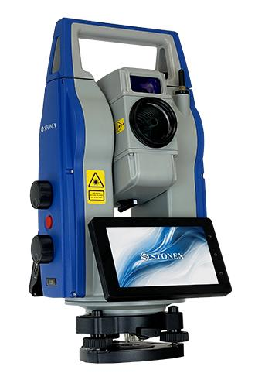
Description
Automatically tracks the survey prism and can be operated remotely by a single surveyor.
Features
- Automatic prism tracking
- Remote control
- High productivity
Applications
- Large construction projects
- Highway surveys
- Precision engineering

3. Reflectorless Total Station
# Source: AI Source: Provided by: [Data Path: Persons Table -> ID Column: 1, Name_En Column: Motasem Essam] -> From: [ChatGPT] on [7/17/2026]
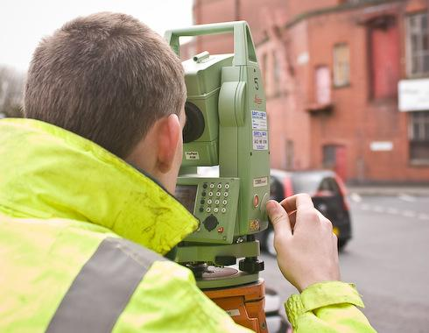
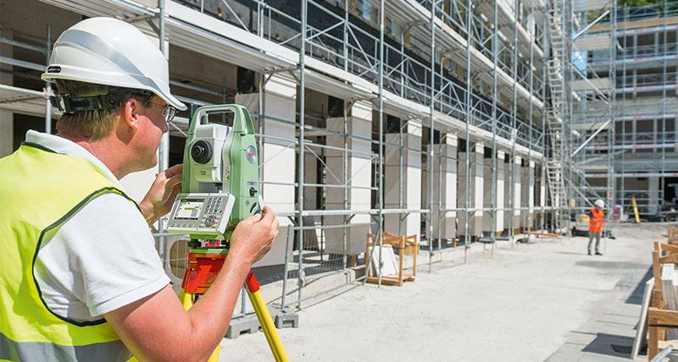
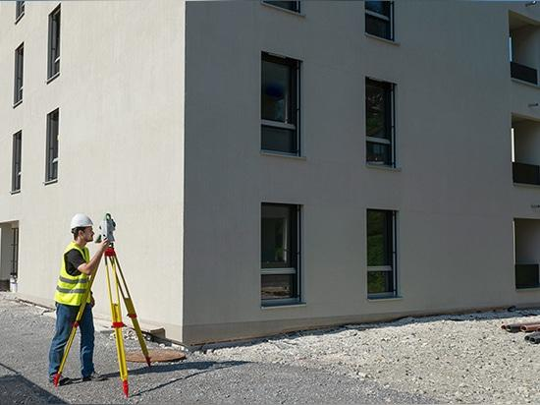
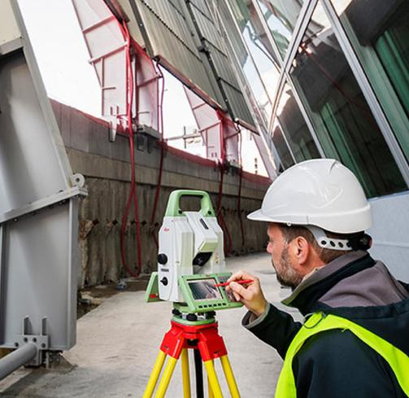
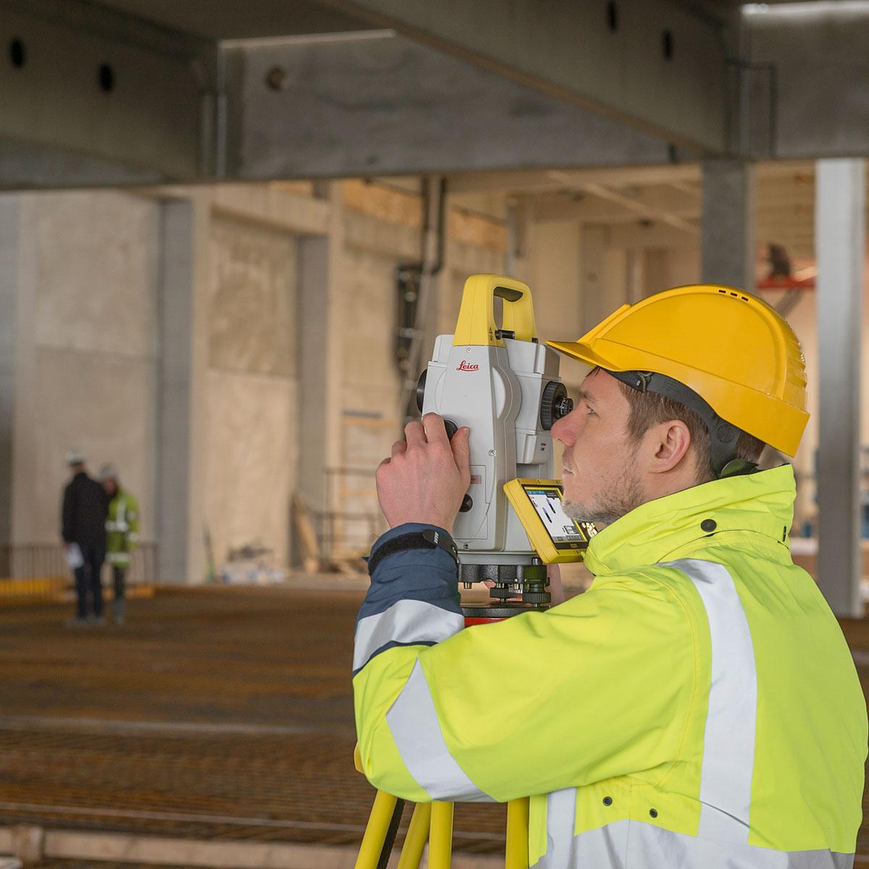
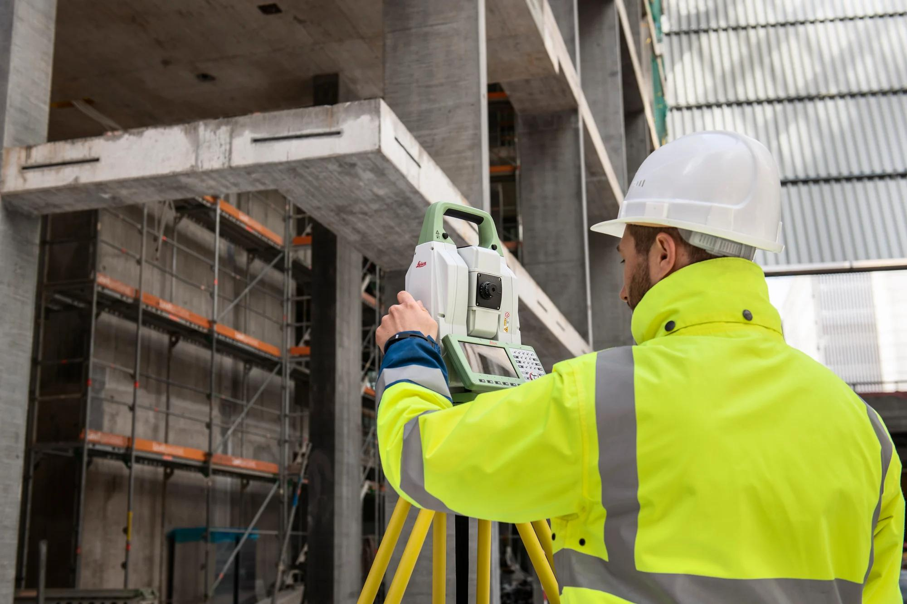
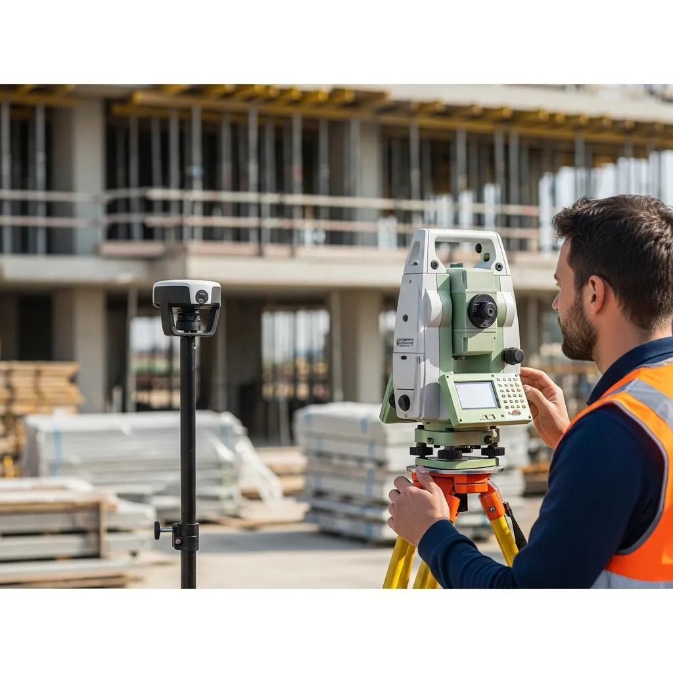
Description
Measures distances without requiring a prism by reflecting a laser directly from the target surface.
Applications
- Building facades
- Hazardous areas
- Difficult-to-reach objects

4. Imaging Total Station
# Source: AI Source: Provided by: [Data Path: Persons Table -> ID Column: 1, Name_En Column: Motasem Essam] -> From: [ChatGPT] on [7/17/2026]
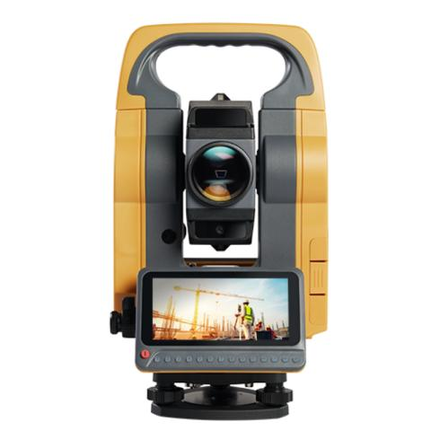
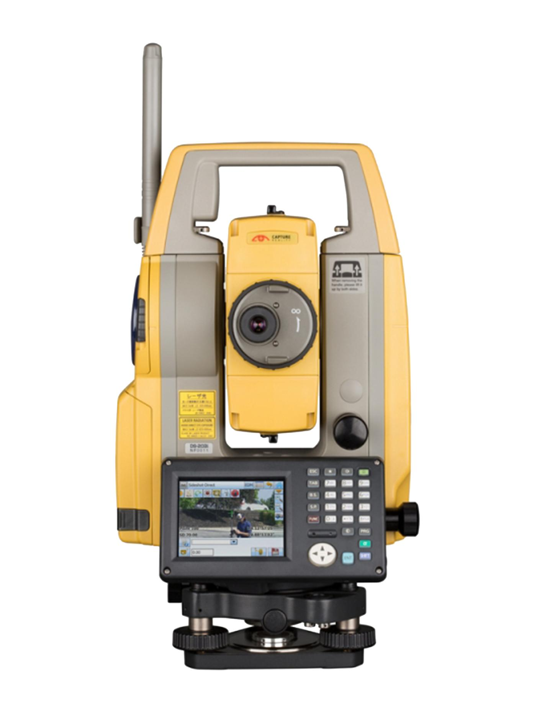
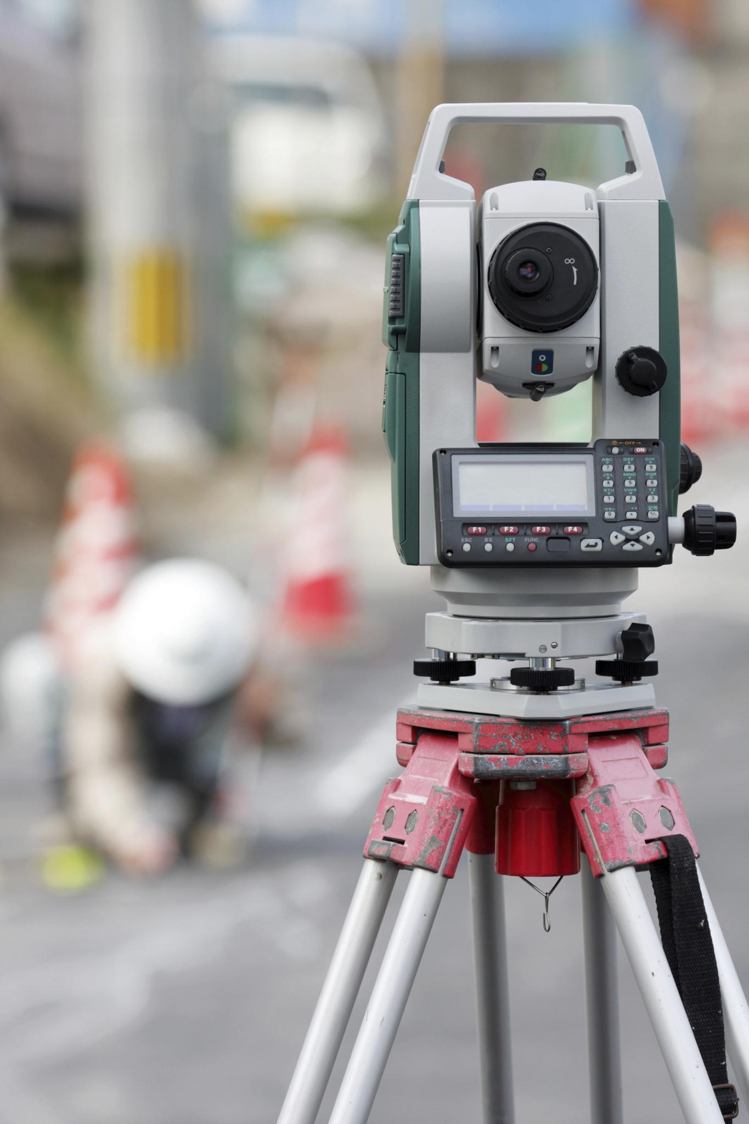
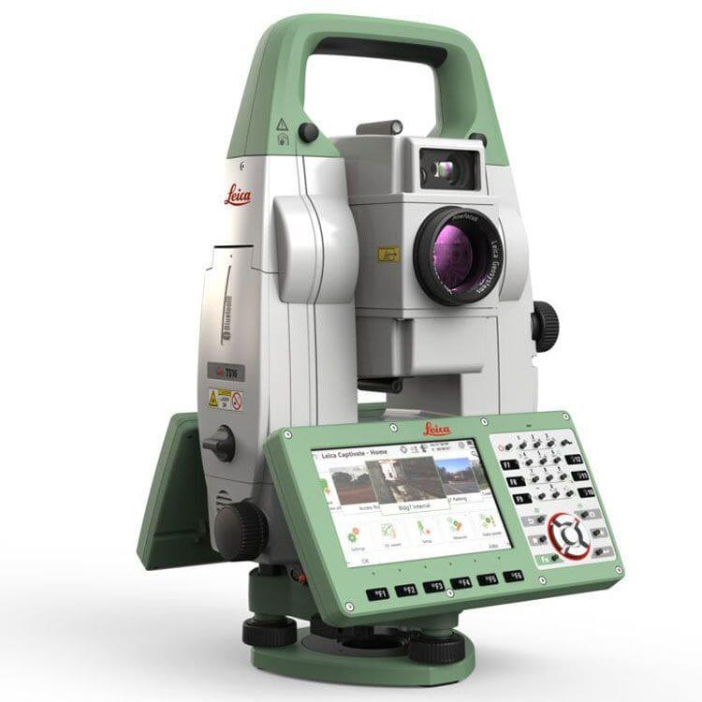
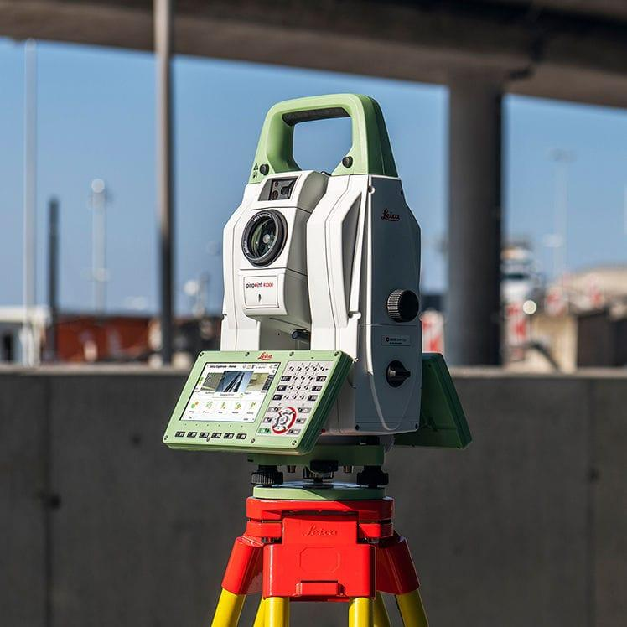
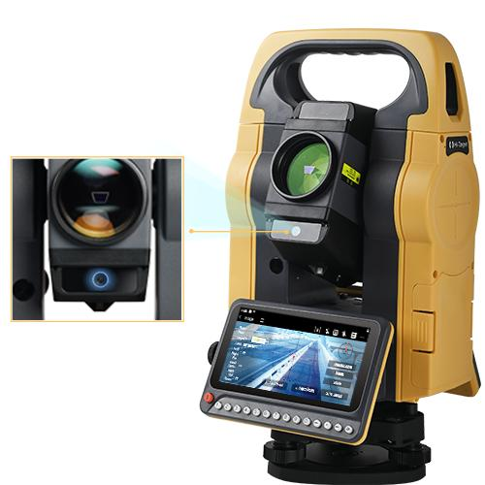
Description
Includes an integrated digital camera for imaging and documentation.
Applications
- Documentation
- Mapping
- Inspection

Measuring Units
# Source: AI Source: Provided by: [Data Path: Persons Table -> ID Column: 1, Name_En Column: Motasem Essam] -> From: [ChatGPT] on [7/17/2026]
A total station measures:
Angles
- Degrees (°)
- Minutes (′)
- Seconds (″)
Distance
- Millimeters (mm)
- Centimeters (cm)
- Meters (m)
Coordinates
- Easting (X)
- Northing (Y)
- Elevation (Z)

Measuring Range
# Source: AI Source: Provided by: [Data Path: Persons Table -> ID Column: 1, Name_En Column: Motasem Essam] -> From: [ChatGPT] on [7/17/2026]
Typical capabilities:
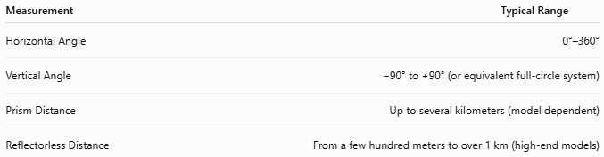
Measurement | Typical Range
Horizontal Angle | 0°–360°
Vertical Angle | −90° to +90° (or equivalent full-circle system)
Prism Distance | Up to several kilometers (model dependent)
Reflectorless Distance | From a few hundred meters to over 1 km (high-end models)

Resolution
# Source: AI Source: Provided by: [Data Path: Persons Table -> ID Column: 1, Name_En Column: Motasem Essam] -> From: [ChatGPT] on [7/17/2026]
Typical resolutions:
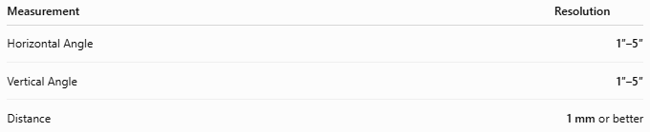
Measurement | Resolution
Horizontal Angle | 1″–5″
Vertical Angle | 1″–5″
Distance | 1 mm or better

Accuracy
# Source: AI Source: Provided by: [Data Path: Persons Table -> ID Column: 1, Name_En Column: Motasem Essam] -> From: [ChatGPT] on [7/17/2026]
Typical accuracy:
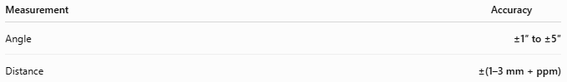
Measurement | Accuracy
Angle | ±1″ to ±5″
Distance | ±(1–3 mm + ppm)
ppm (parts per million) represents a small distance-dependent error component.

How to Use a Total Station
# Source: AI Source: Provided by: [Data Path: Persons Table -> ID Column: 1, Name_En Column: Motasem Essam] -> From: [ChatGPT] on [7/17/2026]
- Mount the total station on a tripod.
- Level the instrument using the leveling screws.
- Center it over the survey point.
- Enter instrument setup information.
- Aim at the survey prism or target.
- Measure the angles and distance.
- Allow the instrument to calculate coordinates.
- Store or export the measured data.

Example
# Source: AI Source: Provided by: [Data Path: Persons Table -> ID Column: 1, Name_En Column: Motasem Essam] -> From: [ChatGPT] on [7/17/2026]
Measured values:
- Horizontal angle = 42° 18′ 12″
- Vertical angle = 12° 40′ 08″
- Distance = 56.432 m
The total station automatically computes:
- X coordinate
- Y coordinate
- Z elevation

Data Storage
# Source: AI Source: Provided by: [Data Path: Persons Table -> ID Column: 1, Name_En Column: Motasem Essam] -> From: [ChatGPT] on [7/17/2026]
Most total stations can store:
- Survey points
- Coordinates
- Instrument settings
- Project files
Many models support:
- USB
- SD card
- Bluetooth
- Wi-Fi
- Cloud synchronization

Applications
# Source: AI Source: Provided by: [Data Path: Persons Table -> ID Column: 1, Name_En Column: Motasem Essam] -> From: [ChatGPT] on [7/17/2026]
Total stations are used in:
- Land surveying
- Construction
- Civil engineering
- Highway design
- Railway construction
- Bridge construction
- Tunnel surveying
- Mining
- Topographic mapping
- Archaeology
- Utility mapping
- Structural monitoring

Advantages
# Source: AI Source: Provided by: [Data Path: Persons Table -> ID Column: 1, Name_En Column: Motasem Essam] -> From: [ChatGPT] on [7/17/2026]
A total station:
- Measures both angles and distances.
- Automatically computes coordinates.
- Stores digital survey data.
- Reduces manual calculations.
- Provides high precision.
- Improves productivity.
- Supports data transfer to CAD and GIS software.

Limitations
# Source: AI Source: Provided by: [Data Path: Persons Table -> ID Column: 1, Name_En Column: Motasem Essam] -> From: [ChatGPT] on [7/17/2026]
A total station:
- Is more expensive than a theodolite.
- Requires batteries.
- Requires operator training.
- Performance may be affected by weather, heat shimmer, heavy rain, fog, or dust.
- Reflectorless measurements may be less accurate on dark or highly reflective surfaces.

Comparison with Other Surveying Instruments
# Source: AI Source: Provided by: [Data Path: Persons Table -> ID Column: 1, Name_En Column: Motasem Essam] -> From: [ChatGPT] on [7/17/2026]
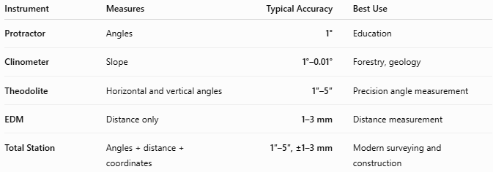
Instrument | Measures | Typical Accuracy | Best Use
Protractor | Angles | 1° | Education
Clinometer | Slope | 1°–0.01° | Forestry, geology
Theodolite | Horizontal and vertical angles | 1″–5″ | Precision angle measurement
EDM | Distance only | 1–3 mm | Distance measurement
Total Station | Angles + distance + coordinates | 1″–5″, ±1–3 mm | Modern surveying and construction

Care and Maintenance
# Source: AI Source: Provided by: [Data Path: Persons Table -> ID Column: 1, Name_En Column: Motasem Essam] -> From: [ChatGPT] on [7/17/2026]
To maintain accuracy:
- Transport in a padded carrying case.
- Keep lenses clean.
- Charge batteries properly.
- Protect from dust and moisture.
- Perform regular calibration.
- Store in a dry, temperature-controlled environment.
- Check leveling and optical alignment periodically.

Common Mistakes
# Source: AI Source: Provided by: [Data Path: Persons Table -> ID Column: 1, Name_En Column: Motasem Essam] -> From: [ChatGPT] on [7/17/2026]
- Incorrect instrument leveling.
- Poor centering over the survey point.
- Wrong prism constant settings.
- Measuring the wrong target.
- Ignoring atmospheric corrections for high-precision work.
- Forgetting to back up survey data.

Key Points
# Source: AI Source: Provided by: [Data Path: Persons Table -> ID Column: 1, Name_En Column: Motasem Essam] -> From: [ChatGPT] on [7/17/2026]
- A Total Station combines:
  - Electronic Theodolite
  - Electronic Distance Meter (EDM)
  - Microprocessor
- It measures:
  - Horizontal angles
  - Vertical angles
  - Distances
- It automatically calculates:
  - Coordinates (X, Y, Z)
  - Elevations
- Common types:
  - Conventional
  - Robotic
  - Reflectorless
  - Imaging
- It is the standard instrument for modern surveying, civil engineering, and construction.

Conclusion
# Source: AI Source: Provided by: [Data Path: Persons Table -> ID Column: 1, Name_En Column: Motasem Essam] -> From: [ChatGPT] on [7/17/2026]
A Total Station is one of the most advanced and versatile surveying instruments available, integrating precision angle measurement, electronic distance measurement, and onboard computing into a single system. By automatically calculating coordinates and storing digital survey data, it greatly improves the speed, accuracy, and efficiency of surveying tasks. Whether used for topographic mapping, construction layout, infrastructure development, mining, or structural monitoring, the total station has become the industry standard for modern geospatial measurement and engineering applications.

